Coordination of Entrepreneurs (2020)
WP3/ Development/3.2. «Entrepreneurs Centres»

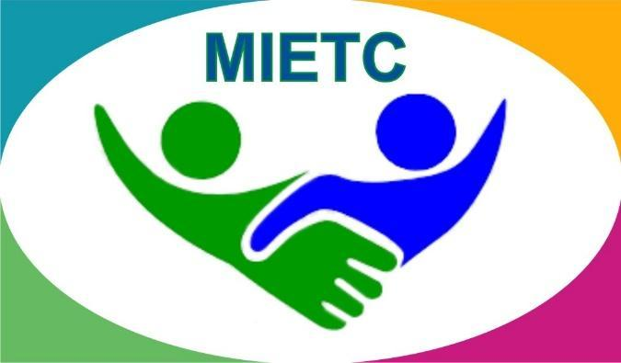
DEVELOPMENT OF A MASTER PROGRAMME IN THE MANAGEMENT OF INDUSTRIAL ENTREPRENEURSHIP FOR TRANSITION COUNTRIES
610198-EPP-1-2019-1-ES-EPPKA2-CBHE-JP

The information and views set out in this publication are those of the authors and do not necessarily reflect the official opinion of the European Union. Neither the European Union institutions and bodies nor any person acting on their behalf may be held responsible for the use which may be made of the information contained therein.

Detailed information is available in the Handbook
https://www.keu.kz/en/section-table/31-materialy/10080-handbook-of-the-entrepreneurs-center.html

Live on the @resourcecenterkeuk resource center Instagram page with Laura Kosaeva, a student of the Social Work specialty @rummynose
On June 9, 2020, from 15:00 h. there was a live broadcast on Instagram on the page of the @resourcecenterkeuk resource center with a student of the Social Work specialty Laura Kosaeva @rummynose. Laura told why she chose KEUK, shared how university education differs from school education; about the experience of passing international and domestic mobility programs, and also shared plans for the future. The meeting was emotional and positive.
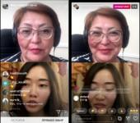

Live on the instagram page of the resource center @resourcecenterkeuk with a student of the specialty Management, Ekaterina Yurkiv @katrinarina_10
On June 3, 2020, from 15:00 h, there was a live broadcast on Instagram on the page of the @resourcecenterkeuk resource center with a student of the specialty "Management" Ekaterina Yurkiv @ katrinarina_10. Catherine reported on the opportunities that the university provides to its students, shared the history of admission and choice of the university. Answered questions of entrants and students.
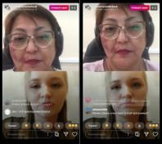

Live on the instagram page of the @resourcecenterkeuk resource center with a representative of the financial center Ishanova Zhibek Sovetbekkyzy @fincenter.kz
May 28, 2020 at 14:00. Live broadcast on the instagram page of the @resourcecenterkeuk resource center with a representative of the financial center Ishanova Zhibek Sovetbekkyzy @ fincenter.kz. The topic of the meeting was the mandatory training of young specialists and PhD doctors who studied on an educational grant. During the live broadcast, graduates had the opportunity to receive answers to all questions of interest. Zhibek also shared personal contacts so that graduates could contact the representative and ask questions personally.
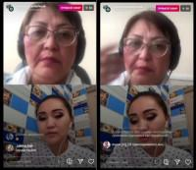

Online meeting with representatives of the Employment Center of Karaganda
May 20, 2020 at 15:00 h. A meeting was held on the ZOOM online site for graduate students with representatives of the Employment Center of Karaganda. Theme of the meeting: participation in the state program "Youth Practice". During the meeting, students asked all questions of interest to the representatives. Questions were asked about timelines, wages, age restrictions, and so on.
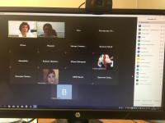

Online meeting with the talent manager of Efes-Kazakhstan JSC Nadezhda Koziyan
May 13, 2020 at 15:00. In the framework of the Vacancy Fair 2020, an online meeting was held at the ZOOM site with the talent manager of Efes-Kazakhstan JSC Nadezhda Koziyan. The topic of the webinar: "Understand yourself better and choose the right profession." The company also talked about a new format of practice in connection with the latest quarantine events and offered a paid online internship for our students.
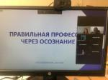

Online meeting with representatives of SJK GROUP LLP
May 13, 2020 at 12:00 h. An online meeting was held at the ZOOM site with representatives of SJK GROUP LLP and with 2-4 year students of our university. The topic of the meeting was practical training with further possible employment in this company. In connection with the expansion of the staff in the construction company, an assistant lawyer, accountant, assistant office manager are required.
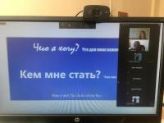

An online meeting with the leader and co-founder of the Automatic Boilers company - boilers «GORNYAK» Berezin Danil
On May 6, 2020, within the framework of the Vacancy Fair 2020, a meeting was held with the head and co-founder of the Automatic Boilers company - boilers «GORNYAK» Danil Berezin. The topic of the meeting was practical training and further work in the production company "Automatic Boilers". The representative eagerly shared about the success of the company, about the volume of production, and also told our students about the functional responsibilities of the employee.
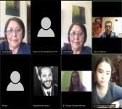
Online meeting with bachelors of students under the state educational grant
On April 17, 2020, an online meeting took place on the ZOOM site with the director of the COMPLETE and CACTLE Resource Center, Kose Janna Komekovna, and graduates of the 2020 bachelor of students studying under the state educational order. The topic of the meeting was distribution for compulsory testing of grants, and all issues regarding the responsibility of graduates to the state were also examined.
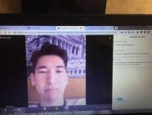
Online meeting with undergraduates studying under the state educational grant
On April 16, 2020, an online meeting took place at the ZOOM site with the director of the COMPLETE and CACTLE Resource Center, Kosе Janna Komekovna, and graduates of 2020 graduate students studying under the state educational order. The topic of the meeting was distribution for compulsory testing of grants, and all issues regarding the responsibility of graduates to the state were also examined.
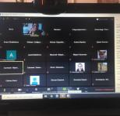
Meeting with students of the educational program "Economics"
On February 25, 2020, as part of the “Week of Economists”, the director of the COMPLETE and CACTLE Resource Center, Kose Zhanna Komekovna, gave a presentation on Stephen Covey’s book “The Seven Skills of Highly Efficient People”. Students were very interested, asked a lot of questions, remained after the end of the presentation, and were also interested in the techniques and exercises proposed by the author of the book. Coverage of passion was very high.
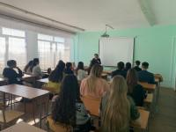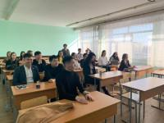

Meeting with representatives of the State Institution "Department of the Agency of the Republic of Kazakhstan for Civil Service Affairs in the Karaganda Region"
February 7, 2020 representatives of the state institution “Department of the Agency of the Republic of Kazakhstan for Civil Service Affairs of the Karaganda Region” held a meeting with students in the framework of the “100 Concrete Steps” project. Civil service specialists informed university graduates about the possibilities and conditions for further employment in the civil service.
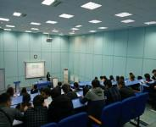

Students and Resource center - new meetings, new plans
On October 8, 2020, at 15:10h and 16:10h, an online meeting was held with students of the final courses of FEME and FBLT on the ZOOM platform. A presentation of the Resource center was held, and issues related to the center's activities were highlighted: organization of internships, employment, job search, resume preparation, etc. Students were particularly interested in questions about employment under the state program "Youth practice" and the distribution of graduates who studied under the state educational order.
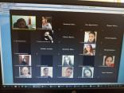

Online meeting of the Resource Center with students, undergraduates and doctoral students of graduate courses of students under the state educational order
On October 14, 2020, at 15:10h, the Resource Center held a meeting with graduate students of all full-time departments of students under the state educational order. The topic of the meeting was the distribution of students and the obligatory processing of the grant. All the moments and stages of distribution were explained to the graduates, they were told about the terms and situations that are exempted from working off. Graduates asked interesting questions. On the same day, at 16:10h, an online meeting was held with undergraduates and doctoral students of graduate courses of students on a state educational order to discuss their distribution and mandatory processing of the grant.
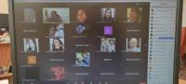

Online meeting of the Resource Center with undergraduates, doctoral students and students of the Faculty of Finance, Logistics and Digital Technologies
On October 12, 2020, the Resource Center held an online meeting at the ZOOM platform with graduates of the master's and doctoral studies of the next year. During the meeting, the center provided information on its activities, highlighted all issues of further employment. The center also told what help they can provide in helping to find a job.
On October 13, 2020, an online meeting was held with graduate students of the Faculty of Finance, Logistics and Digital Technologies at the ZOOM platform. The center told what support it can provide for students for their further employment, made a presentation of the center, talked about electronic platforms where you can find vacant positions.


Job Fair: meeting with JSC "Kazpost" and JSC "Kazakhstelecom"
On November 11, as part of the Job Fair, an online meeting was held at the ZOOM site with representatives of JSC "Kazpost". Of course, we all know what a postman does and how. But what and how does everyone else do in such a large company? We found out about this at the meeting. And they also shared with us information about the implementation of important strategic goals. And each of us can be involved in any of them, it's a franchise, it's additional services, etc. Great! And at the same time, you can build your own business!!!
Each of us uses both the phone and the Internet! Dear graduates of KEUK, if you could not attend the meeting, but you have questions about this company, if you are interested in the opportunity to work there, take a look at the Resource Center, and we will tell you everything! We are waiting for you in room 107
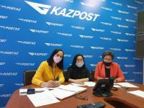
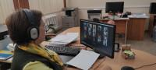

Job Fair: where to go to work?
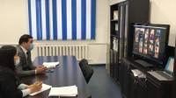
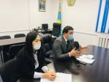 | 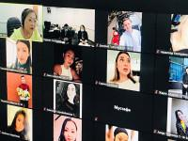

On November 19, 2020, an online meeting will be held with representatives of the KSU "Employment Center of the Akimat of the city of Karaganda". The meeting was also attended by companies participating in the implementation of the state program "Youth Practice": TC Megapolis-Kazakhstan LLP, Rem Stroy Portal LLP, Ozon-integra LLP, Story Logistic KZ LLP, Grandiz LLP, Kaz metiz Kaz-Metiz LLP, Amagel LLP, Neftai - Company LLP, Deltaprom KZ LLP, Cosmonaut Hotel LLP. (Job Fair)

Job Fair: meeting with the KSU "Employment Center of the Akimat of the city of Karaganda"
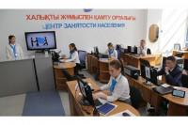
The program "Youth Practice" has been operating for several years.
And it gives good results. This was announced on November 24, 2020 by the director of the Employment Center of Karaganda, N.H. Syzdykov. More than 70 graduates of 2020 are working under the program "Youth Practice".
What is a good program for graduates?
1. Official employment.
2. The employment center helps you find a job in your specialty.
3. Employers' interest in attracting young professionals.
4. Constant consultation of students on the issues of youth practice.
5. The possibility to switch to a permanent job in the company earlier than 6 months.
6. The possibility of receiving recommendations from the place of youth practice.
7. Obtaining initial work experience in the specialty.
This is what was discussed at the meeting. The audience has gathered great! About 100 of our students attended the meeting. Representatives of the Chamber of Entrepreneurs "Atameken" also took part in the meeting. Companies that are ready to offer vacant positions to students, as well as forming a personnel reserve were also invited to the Job Fair: SB Kurmet Arlan Plus LLP, SPM-25 LLP, BALIS GROUP LLP, Apex Stroy LLP, Sary-Arka LLP, Asia Creative LLP, Raduga LLP, Gas Station Service Karaganda LLP, Hermes Bursa LLP, KazKomir Trade LLP, Denzar LLP, Household Appliances Plant LLP, Qaz Met Group LLP.
Dear graduate students of KEUK, we really hope that this information will be not only interesting for you, but also relevant. And that some of you will start your professional career in 2021, including under this program.

Job Fair: Temirtau City Police Department
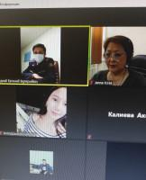
Why is it very prestigious to serve in the police?
- stable operation;
- social guarantees;
- the possibility of career growth;
- irregular working hours;
- the possibility of self-realization;
- a decent salary.
Another online meeting within the framework of the job fair was held last week with representatives of the Temirtau city Police Departments. Students and undergraduates of the final courses of the specialties "Jurisprudence", "Customs" were invited. Representatives answered all questions concerning the stages of admission to work. If you didn't have time for a meeting, but still want to test yourself in this area, then come to the Resource Center in room 107 and we will tell you what to do.

